Software Architecture & Design Specification
Simple-Shell (Command Line Interpreter)
Version: 1.0
Authors: Diya (Team Lead), Debhargo, Aarush, Prithviraj
Date: [Fill Date]
Status: Draft

Revision History
Version | Date | Author | Change Summary
1.0 | [Fill Date] | Diya, Debhargo, Aarush, Prithviraj | Initial draft

Approvals
Role | Name | Signature/Date
Team Lead | Diya
Developer | Debhargo
Developer | Aarush
Developer | Prithviraj

1. Introduction

1.1 Purpose
This document specifies the software architecture and detailed design of Simple-Shell, a Unix-like command-line interpreter written in C. It complements the Software Requirements Specification (SRS) by describing how the system is structured internally to satisfy those requirements.

1.2 Scope
Covers the internal architecture of the shell: its components, their responsibilities and interactions, the chosen architecture pattern, the security architecture, and the detailed design of key flows (command execution and piping), including API-level interfaces between components and error-handling strategy.

1.3 Audience
Developers (Diya, Debhargo, Aarush, Prithviraj), course instructors/evaluators, and any future maintainer extending the shell.

1.4 Definitions
REPL, fork, exec, wait, pipe, dup2, PATH, STRIDE, RTM. See the SRS Appendix A for the full glossary.

2. Document Overview

2.1 How to Use This Document
Section 3 (Architecture) describes the system's component structure, the architectural pattern chosen, technology stack, risks, traceability to requirements, and security architecture. Section 4 (Design) drills into two representative flows with UML sequence diagrams, the internal API design between components, and the error-handling strategy.

2.2 Related Documents
Software Requirements Specification (SRS) v1.1, Software Test Plan (STP) v1.0, project README and Requirement Traceability Matrix (SRS Appendix C).

3. Architecture

3.1 Goals & Constraints
Goals: correctness of core POSIX shell semantics, reliability (no crashes/zombies), portability across POSIX systems, and a codebase simple enough for four students to divide and understand.
Constraints: must be written in C using only standard POSIX system calls; no third-party shell libraries; no GUI; must build with a single make command.

3.2 Stakeholders & Concerns
- End users — correctness, responsiveness, clear error messages.
- Course evaluators — adherence to specification, code quality, demonstrable understanding of OS concepts.
- Development team — modularity (so four people can work in parallel), maintainability.

3.3 Component (UML) Diagram
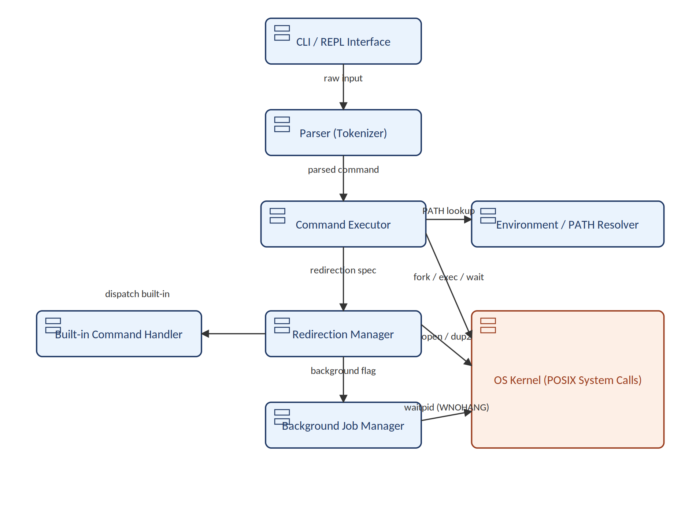

3.4 Component Descriptions
- CLI / REPL Interface: owns the prompt/read/execute loop; the user-facing entry point. Owner: Prithviraj.
- Parser (Tokenizer): converts a raw input line into a structured Command (argv, redirection targets, pipeline stages, background flag). Owner: Aarush.
- Command Executor: dispatches to the Built-in Command Handler or forks/execs external programs, including piping between chained commands using pipe()/dup2(), managing exit-status reporting. Owner: Debhargo.
- Built-in Command Handler: implements cd, exit, pwd, echo, help directly in the shell's own process. Owner: Prithviraj.
- Redirection Manager: opens redirection targets (<, >, >>) and wires the correct file descriptor via dup2(). Owner: Diya.
- Background Job Manager: tracks background job IDs/PIDs and reaps finished background jobs without blocking the prompt (waitpid with WNOHANG). Owner: Aarush.
- Environment / PATH Resolver: resolves bare command names against PATH and exposes environment variables to children. Owner: Diya.
- OS Kernel (POSIX System Calls): external system providing fork, exec, wait, pipe, dup2, and file I/O.

3.5 Chosen Architecture Pattern and Rationale
A layered, pipeline-style architecture was chosen: each command line flows through clear layers — REPL → Parser → Executor (including piping) → Redirection Manager → Background Job Manager — mirroring how real Unix shells are structured internally. This was chosen over a monolithic single-file design because it lets the team own and unit-test separate layers independently, with module boundaries redrawn once during planning to balance workload across the team (background execution moved to its own component owned by Aarush, piping absorbed into the Command Executor owned by Debhargo) without changing the overall layered flow. It maps naturally onto the sequence of system calls a shell must make for any command. A microservice or event-driven architecture was considered and rejected as unnecessary complexity for a single local process with no concurrency beyond OS-level process forking.

3.6 Technology Stack & Data Stores
- Language: C (C99), compiled with GCC.
- Build: GNU Make (single Makefile).
- OS interfaces: POSIX system calls (fork, execvp, wait, pipe, dup2, open/close).
- Data stores: none persistent — the shell is stateless between invocations, aside from an in-memory command history list (stretch goal) held only for the current session.

3.7 Risks & Mitigations
Risk | Mitigation
Zombie/orphaned processes from unreaped children | Always pair fork() with a corresponding wait()/waitpid() unless explicitly backgrounded; track background PIDs
File descriptor leaks across pipelines | Close every unused pipe end immediately after dup2() in both parent and child
Shell crash on malformed input | Centralized input validation in the parser; defensive checks before every system call
Platform differences (Linux vs macOS vs Windows) | Target POSIX-only APIs; develop/test primarily on Linux or WSL2

3.8 Traceability to Requirements
Full requirement-by-requirement detail is in the SRS Appendix C; the table below maps each requirement group to the owning component(s).
Requirement | Description | Component(s)
REQ-1–REQ-4 | REPL loop and built-in commands | CLI / REPL Interface, Built-in Command Handler (Prithviraj)
REQ-5–REQ-8 | Parsing and tokenization | Parser / Tokenizer (Aarush)
REQ-9–REQ-12 | External command execution | Command Executor (Debhargo)
REQ-13–REQ-15 | I/O redirection | Redirection Manager (Diya)
REQ-16–REQ-17 | Piping between chained commands | Command Executor (Debhargo)
REQ-18–REQ-19 | Background execution and job tracking | Background Job Manager (Aarush)
REQ-20 | Environment variable / PATH handling | Environment / PATH Resolver (Diya)
REQ-SEC-1–SEC-4 | Security requirements | Command Executor, Redirection Manager (see §3.9)

3.9 Security Architecture
Threat modeling using STRIDE, applied to the shell's trust boundary (user input and the file system):
- Spoofing: not directly applicable (no authentication subsystem); mitigated by running strictly under the invoking user's own OS identity, never assuming another identity.
- Tampering: a malicious redirection target or pipeline could overwrite unintended files; mitigated by REQ-SEC-2 (path validation before open()).
- Repudiation: out of scope for a local single-user tool with no audit requirement in this version; noted as a future enhancement (command logging).
- Information Disclosure: environment variables could leak sensitive data if echoed automatically; mitigated by REQ-SEC-3 (no implicit env logging).
- Denial of Service: unbounded input or fork-bombs via background jobs could exhaust system resources; mitigated by REQ-SEC-4 (input/argument length limits) and by waiting on/tracking all spawned PIDs (REQ-19).
- Elevation of Privilege: mitigated by REQ-SEC-1 (never using setuid/setgid or any privilege-elevating call).

4. Design

4.1 Design Overview
The shell is designed as four cooperating modules communicating through a shared, in-memory Command data structure, with no module calling another's internals directly — only its published functions (see §4.3 API Design). This keeps each module independently testable, which was essential given the team split ownership of modules by difficulty (see SRS Appendix C).

4.2 UML Sequence Diagrams

4.2.1 Sequence 1: Executing an external command (e.g., “ls -l”)
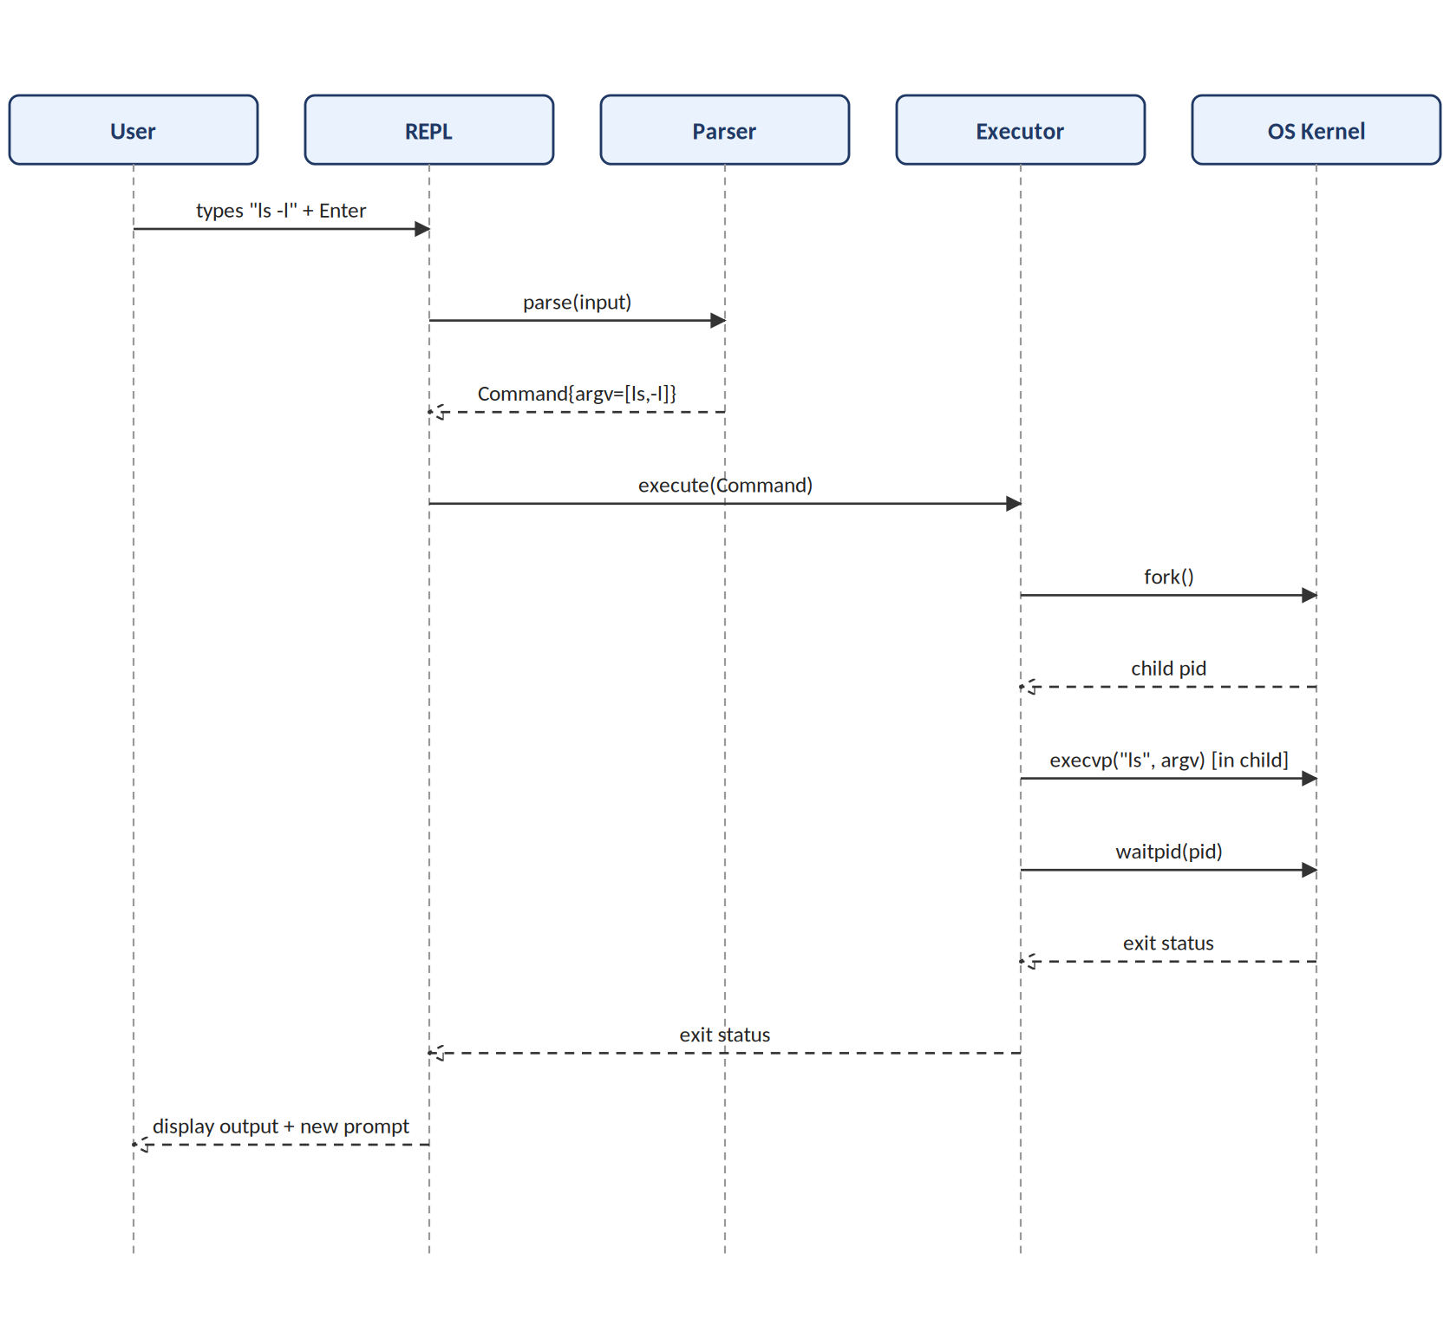

4.2.2 Sequence 2: Piping two commands (e.g., “cat file | grep text”)
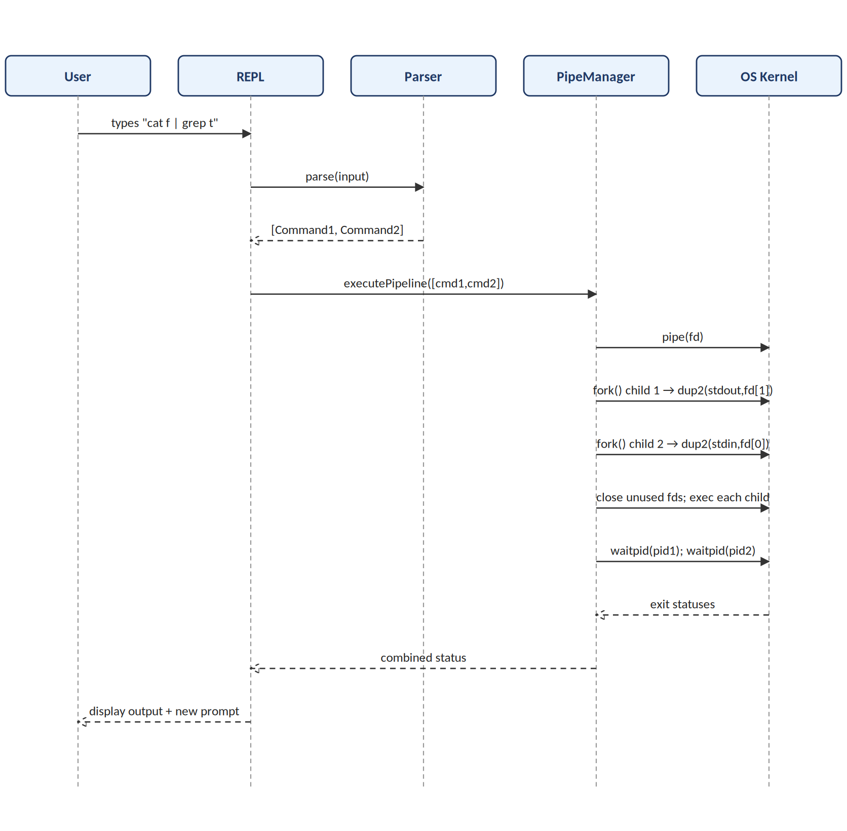

4.3 API Design
Internal C function-level “APIs” between the major components (not network APIs, since this is a single local process):

Component: Parser
Function: Command *parse_input(const char *line);
Input: a raw null-terminated input line from the REPL.
Output: a heap-allocated Command struct containing argv[], an optional input/output redirection filename and mode, a pipeline link to the next Command (or NULL), and a background flag.
Errors: returns NULL and sets parser_errno on malformed quoting; caller (REPL) prints the corresponding message.

Component: Command Executor
Function: int execute_command(Command *cmd);
Input: a single parsed Command (already resolved for redirection by the Redirection Manager if applicable).
Output: an integer exit status (0–255), mirroring the POSIX convention from wait().
Errors: returns -1 with errno set if fork() fails; prints “command not found” and returns 127 if exec() fails (matching standard shell convention).

4.4 Error Handling, Logging & Monitoring
- All system call failures (fork, exec, open, pipe) are checked against -1/NULL and reported via a single centralized perror-style error function, never left unchecked.
- Error messages are written to standard error (not standard output) so they can be distinguished and redirected independently.
- No sensitive data (environment variable values, file contents) is included in error messages beyond what the user's own command already exposed.
- Monitoring for this coursework project is limited to manual testing and the test logs defined in the Software Test Plan; no production-style telemetry is in scope.

4.5 UX Design
The interface is intentionally minimal: a single-line text prompt (myshell> ), synchronous echoing of typed input (handled by the terminal), and error messages prefixed clearly enough to distinguish them from normal output. No colour, GUI, or graphical elements are in scope for this version.

4.6 Open Issues & Next Steps
- Decide on exact history buffer size and whether history persists across sessions (stretch goal).
- Decide on job-control depth for background processes (e.g., whether fg/bg commands are in scope).
- Finalize the exact wording/format of all user-facing error messages for consistency across modules.

5. Appendices

5.1 Glossary
REPL, fork, exec, wait, pipe, dup2, PATH, STRIDE — see SRS Appendix A for full definitions.

5.2 References
- Simple-Shell SRS v1.1
- Simple-Shell Software Test Plan v1.0
- IEEE 42010 (architecture description practice, referenced structurally)
- POSIX.1 system interface documentation

5.3 Tools
- Diagrams: hand-drawn UML (component, use case, sequence) per this document's figures.
- Build/test: GCC, GNU Make, Bash (test_cases.sh).

